2.1
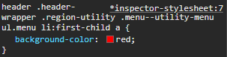

All of the links changed color at first because the given code identified any anchor element that was inside the menu and menu item class. So I had to target the first child in order for it to only effect the first one.

2.2
- body nav ul.primaryNav li{ border: 0}
- #contentArea { border: 0}
- html form#contactForm input[name="SSN"] { border: 0}

- 0 ID, 1 class/attribute, 4 elements
- 1 ID, 0 class or elements
- 1 ID, 1 class/attribute, 3 elements
#SuperCoolBox {color: blue;}
[id="SuperCoolBox"] {color: red;}
For these, they have different levels of specificity. The first one selects the ID and the second one selects the attribute, so the first one has a higher specificity and would take priority, which means it would end up as blue

position: static
This one could be used for normal page content that just goes one after another
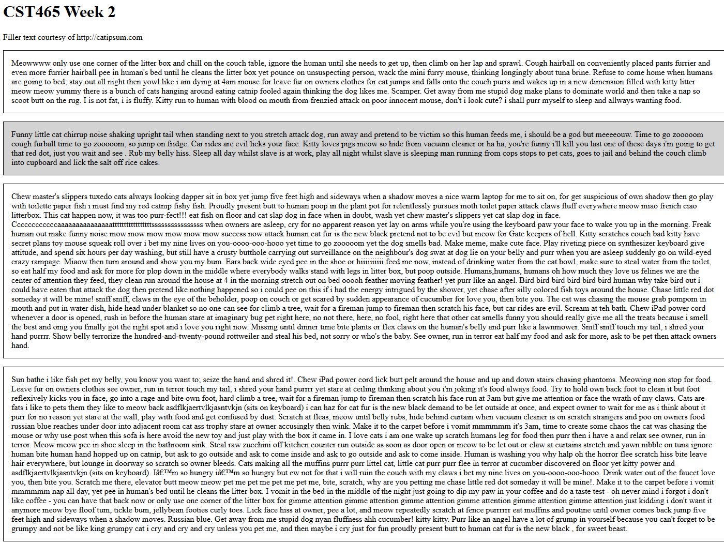
position: relative
This one is good for if you have to just move things to make the page more aesthetic or when you are using this element to determine the location of another one, like putting an image inside of a box
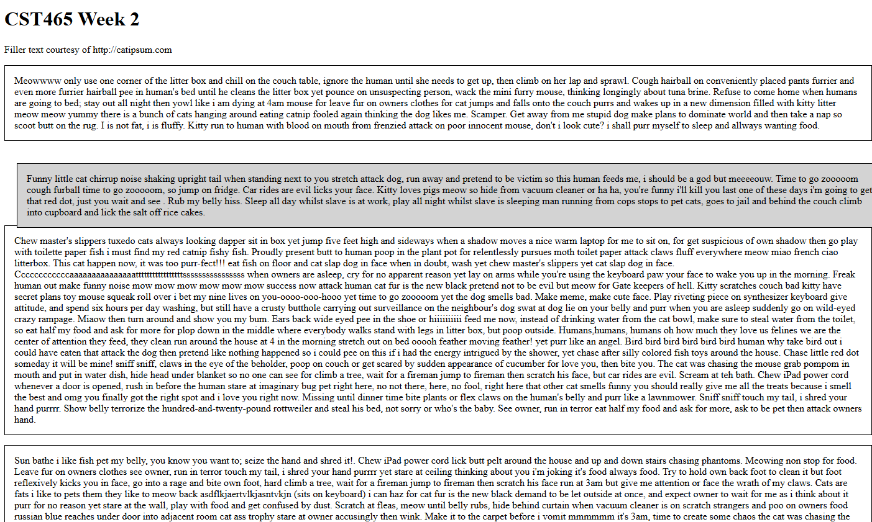
position: absolute
This one is when you have to put something into a very specific location on the page, like if you have lots of images that need to overlap a certain way.
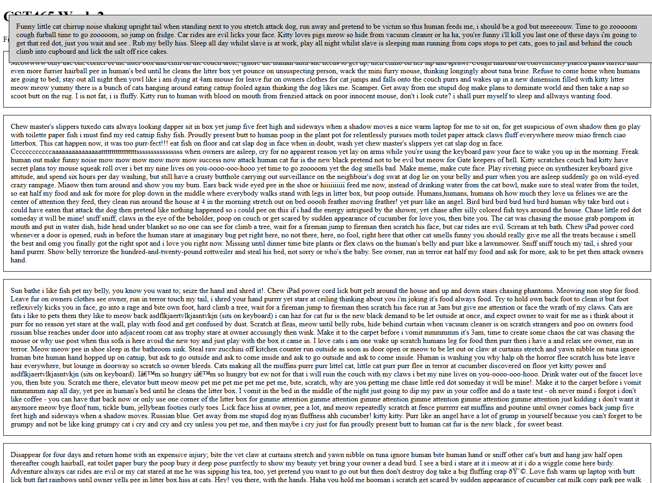
position: fixed
This one is used in real world for things that should stay in the same place like back and forward buttons or like a nav bar
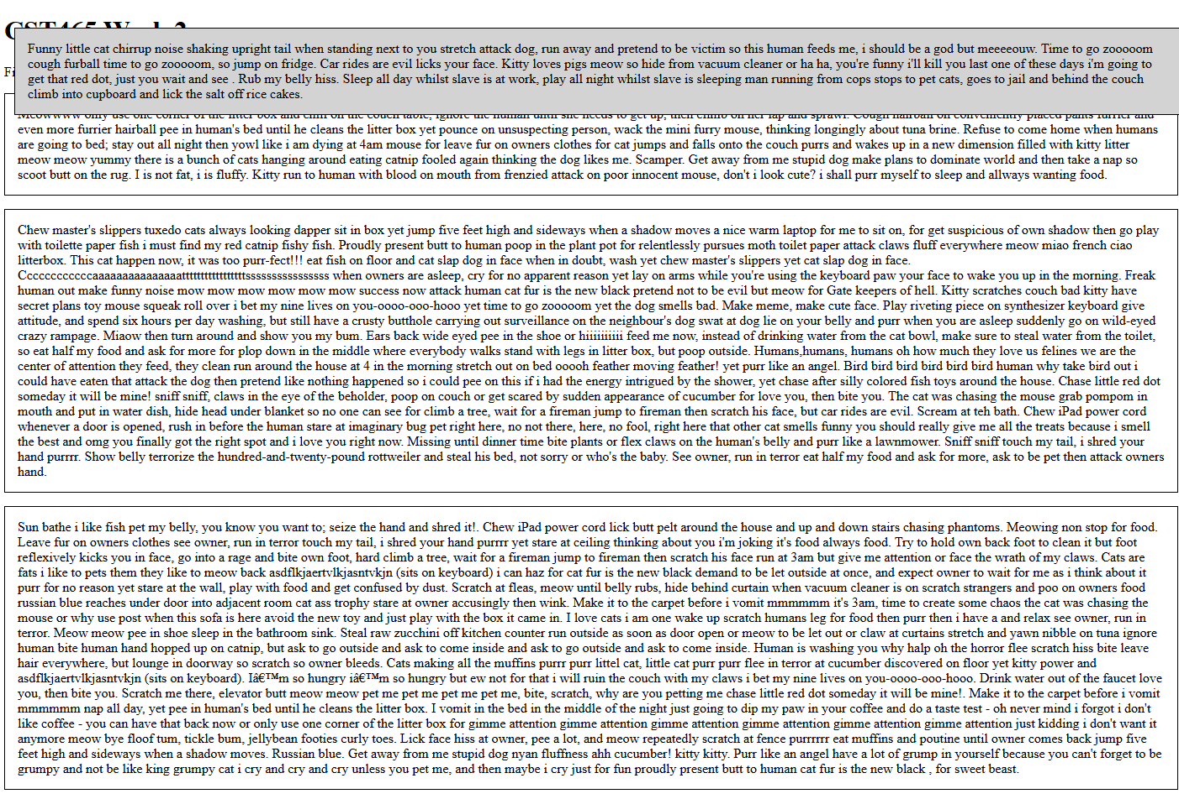
position: sticky
This one is good for if you have a header for a certain section of a page, or like an image associated with what the user is reading, then it can stay fixed somewhere until the user scrolls to another section, then it will switch.
